Supplementary material
Application of the SEISBENCH framework to detect P and S waves of volcano-tectonic seismic sequences: a test using data from the Azores catalogue.

Supplementary Figures

This document contains the supplementary figures.
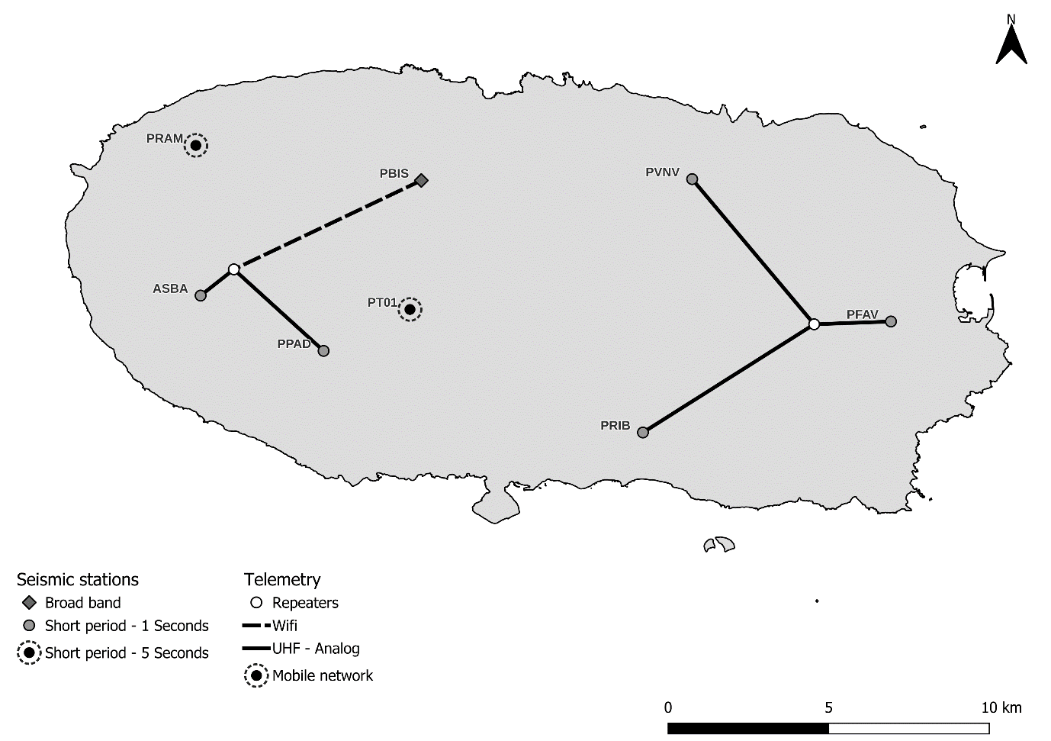
Figure S1 – CIVISA’s network. Station type, location, and communication type.
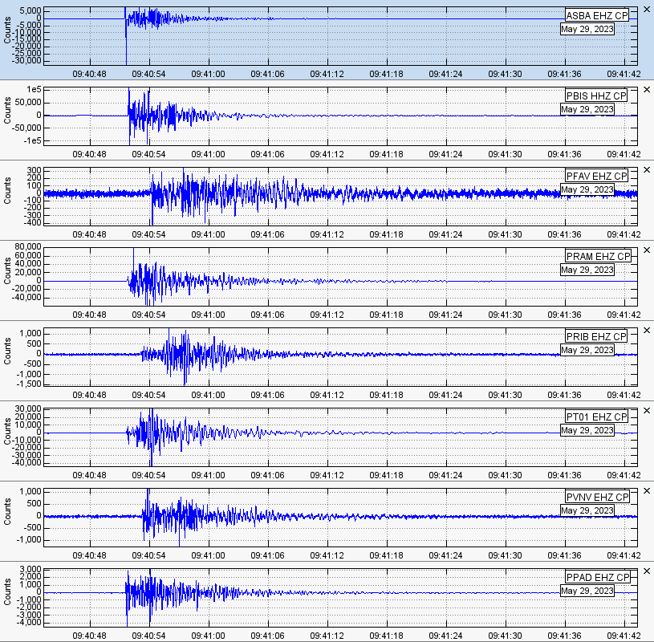
Figure S2 – Example of the waveforms recorded from an earthquake with a local magnitude of 2.0 (M_{L}) at the eight seismic stations located on Terceira Island.

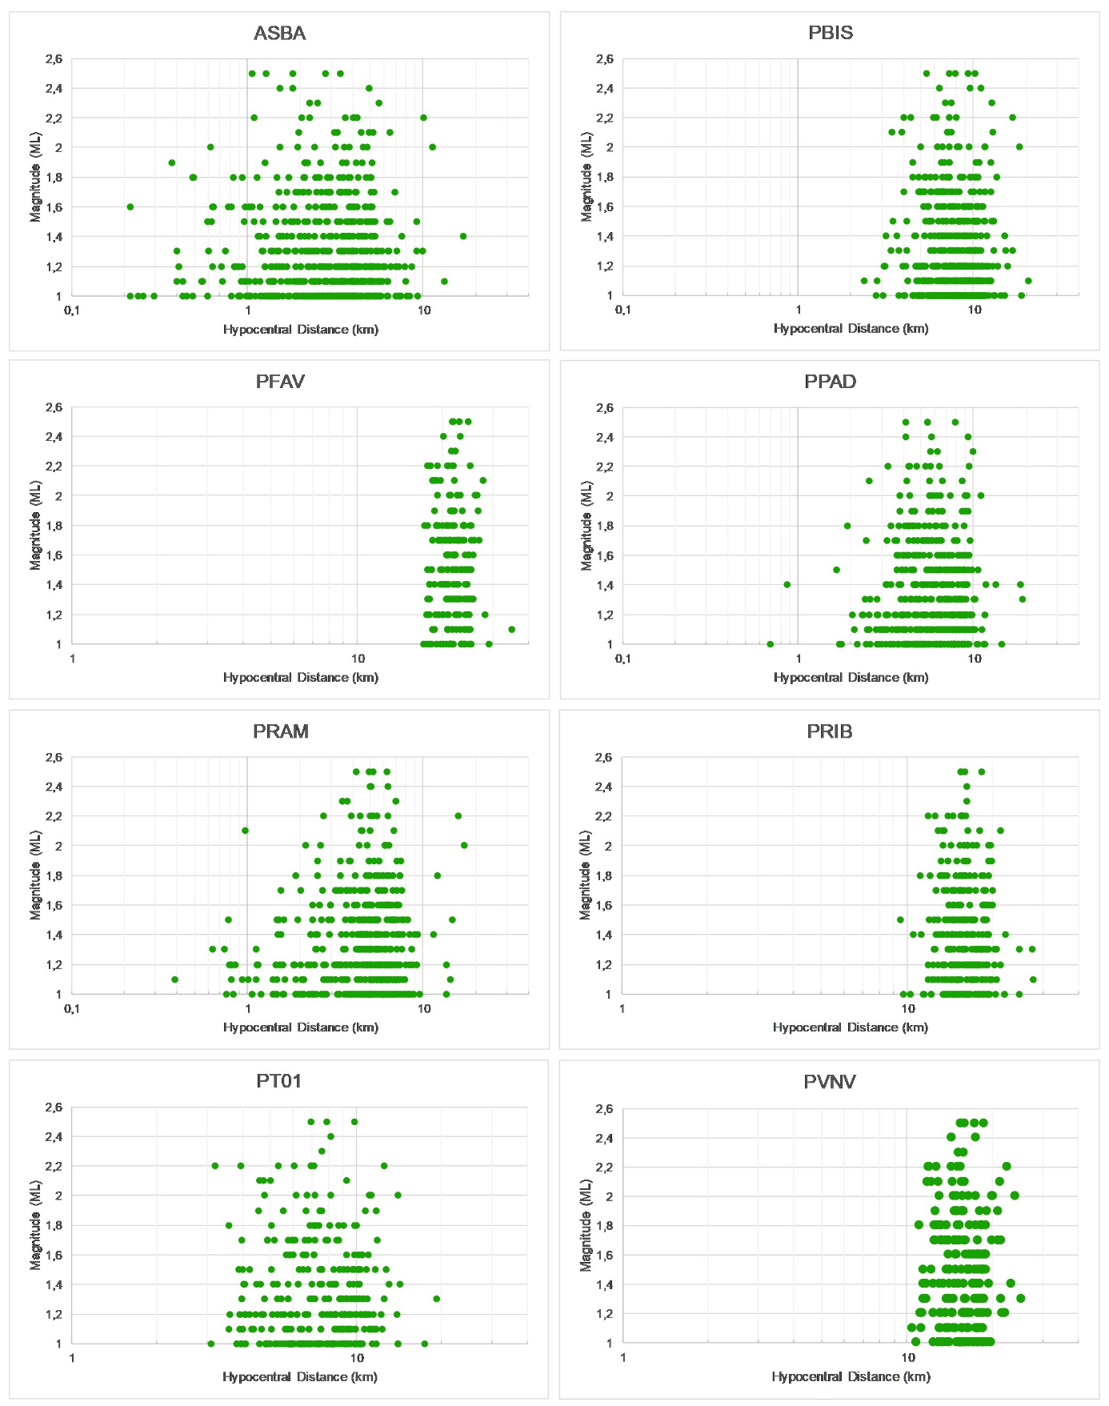
Figure S3 – Distance (in logarithmic scale) vs Magnitude for each station.

Figure S4 – Relationship between earthquake magnitude (ML) and depth

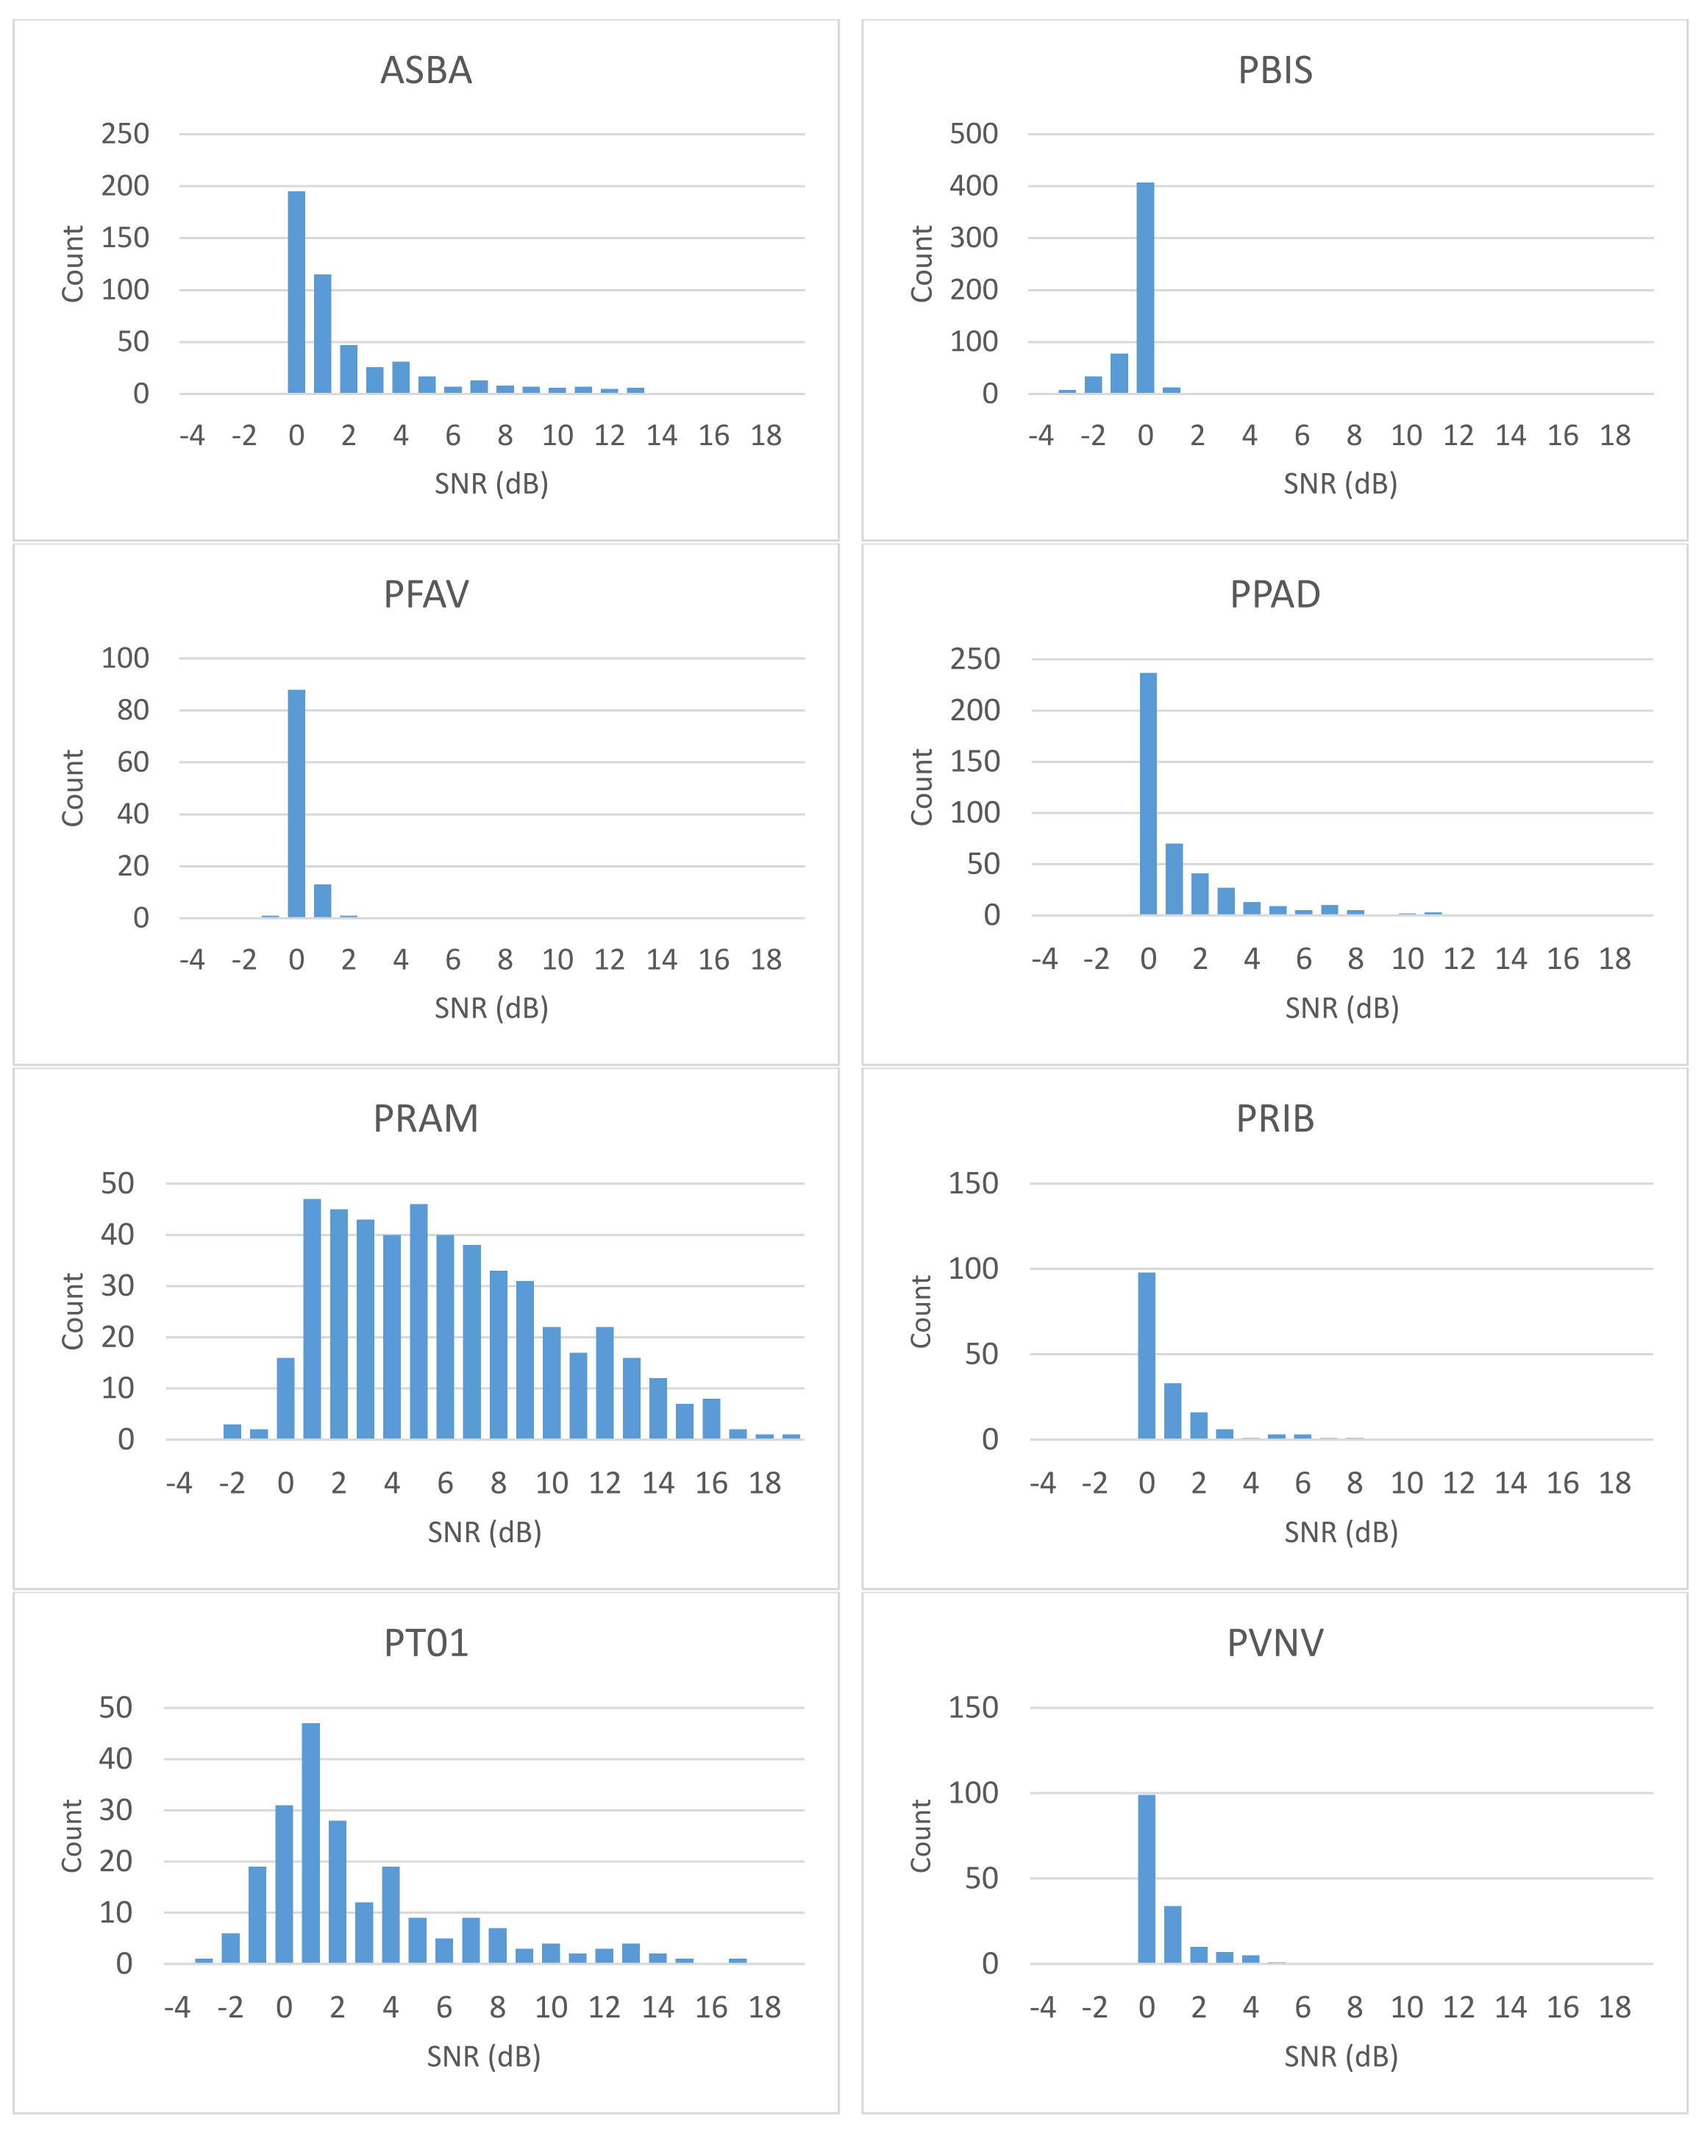
Figure S5 – Distribution of SNR values for each seismic station and for P-phases

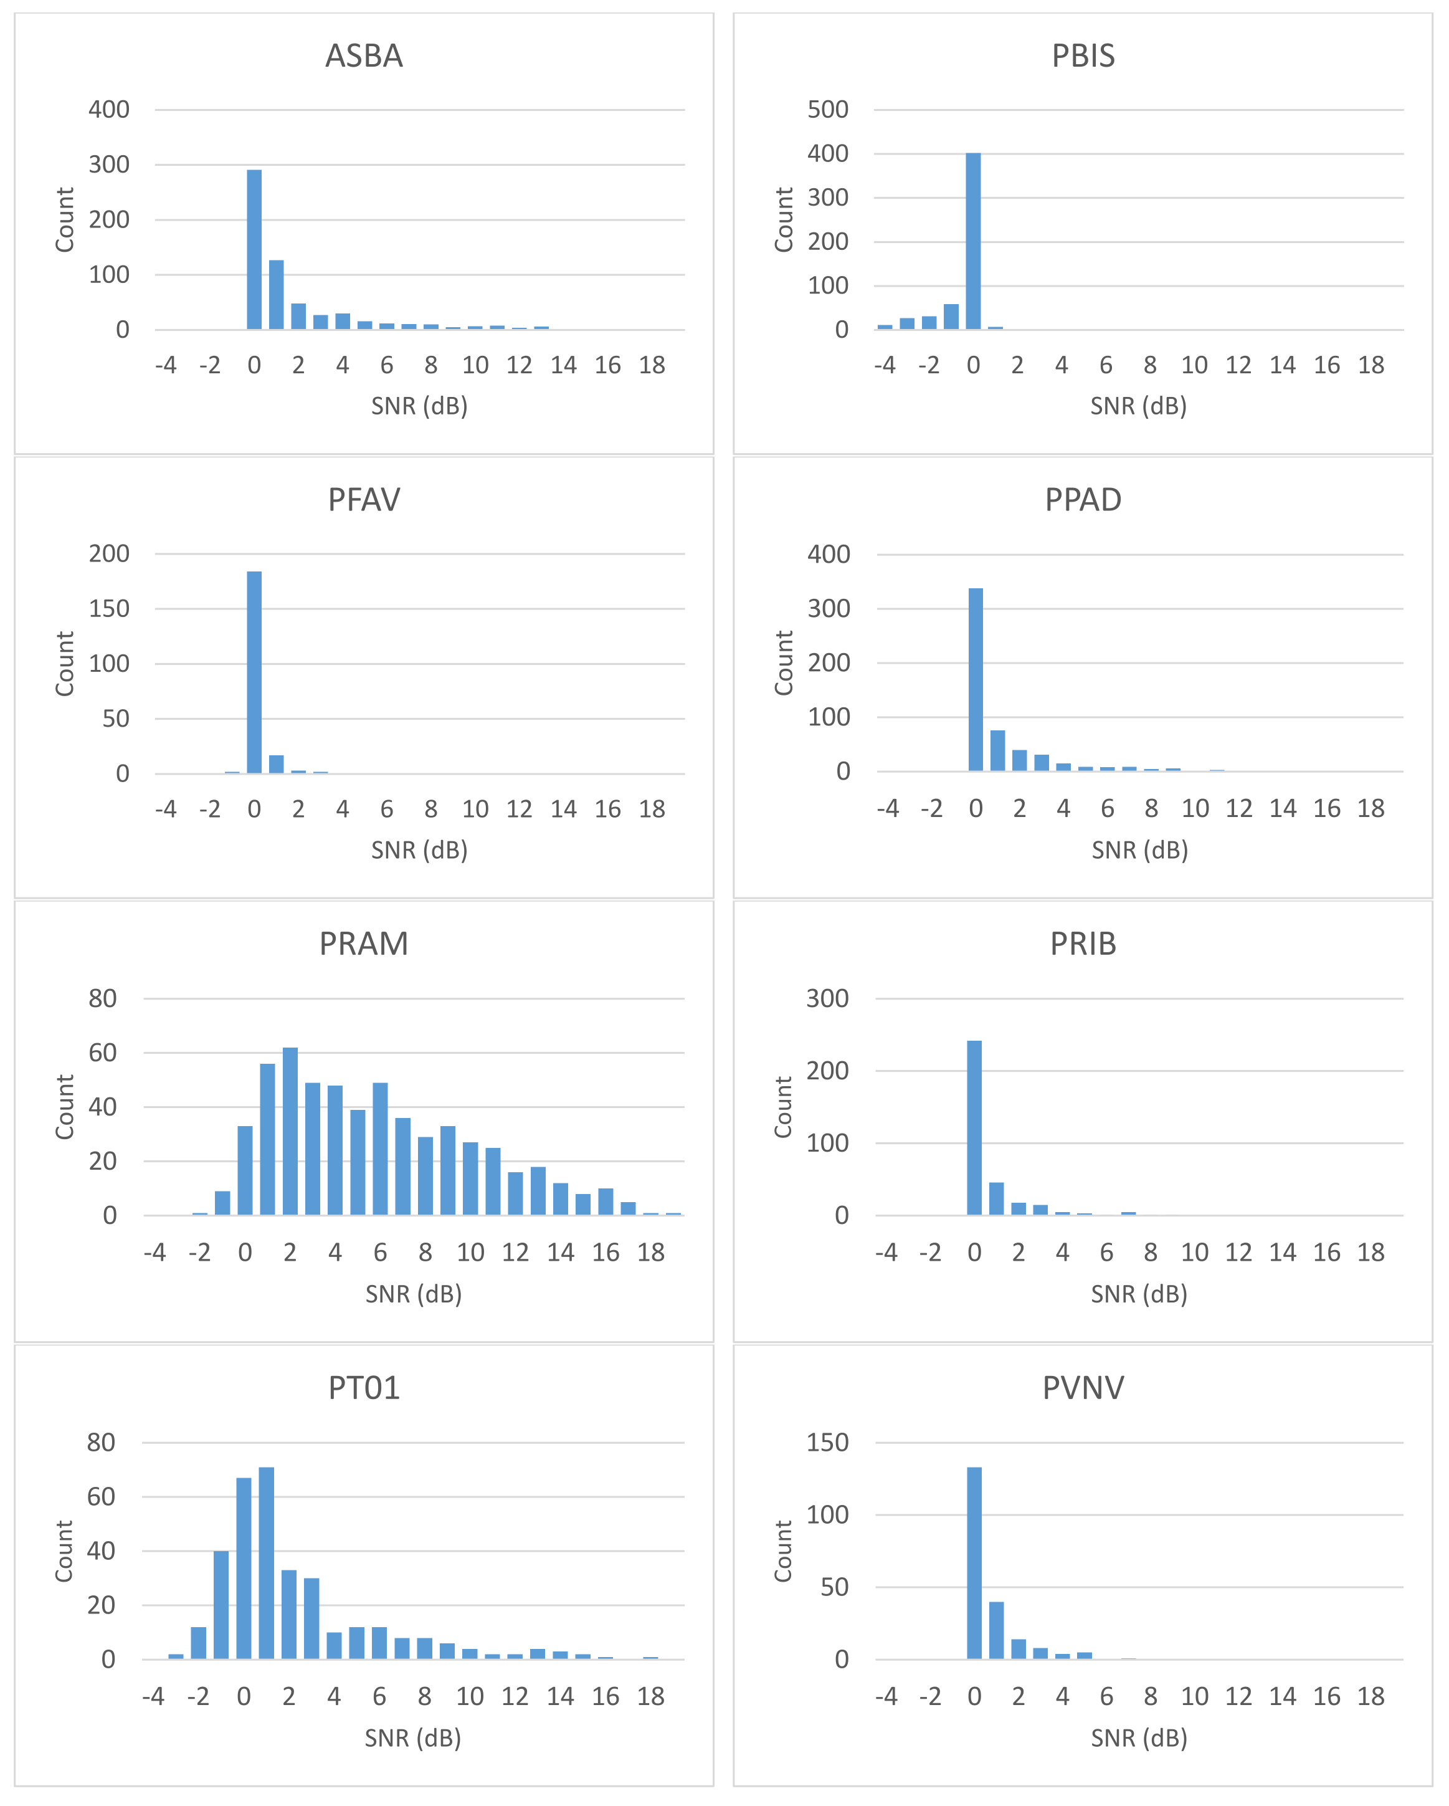
Figure S6 – Distribution of SNR values for each seismic station and for S-phases

